**Obstacle Avoiding Robot**

INTRODUCTION:

Robotics is an interesting and fast-growing field. Being a branch of engineering, the applications of robotics are increasing with the advancement of technology.

The concept of Mobile Robot is fast evolving and the number of mobile robots and their complexities are increasing with different applications.

There are many types of mobile robot navigation techniques like path planning, self – localization and map interpreting. An Obstacle Avoiding Robot is a type of autonomous mobile robot that avoids collision with unexpected obstacles.

In this project, an Obstacle Avoiding Robot controlled by a bluetooth enabled joystick is designed. It is an

Arduino based robot that uses Ultrasonic range finder sensors to avoid collisions.

HARDWARE REQUIRED:

**1. CAR**

Arduino Uno

Motors (2): 5V operated

Robot Chassis

Motor Driver IC – L293

Bluetooth Module- HC-05

Micro Servo Motor

Ultrasonic Range Finder Sensor- HC-SR04

Lithium Battery (2): 3.7V

Jumper Wires

COMPONENT DESCRIPTION:

**1. Arduino Uno**

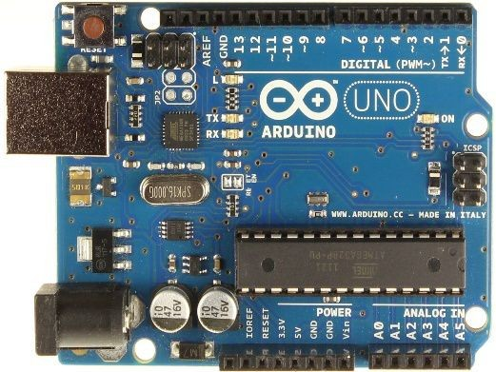Arduino Uno is an ATmega 328p Microcontroller based prototyping board. It is an open source electronic prototyping platform that can be used with various sensors and actuators.Arduino Uno has 14 digital I/O pins out of which 6 pins are used in this project.

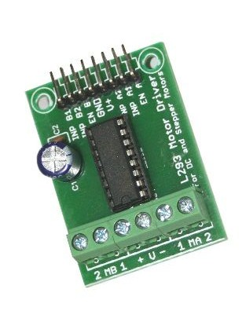**2. Motor Driver IC – L293**

It is a motor driver which can provide bi-directional drive current for two motors.With bi- directional current, we can move the two motors in either direction i.e. forward, backward, left, right, clockwise rotation, anticlockwise rotation.

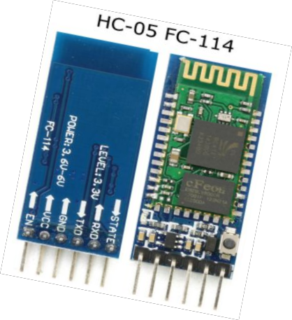**3. Bluetooth Module-HC05**

HC-05 module is an easy to use Bluetooth SPP (Serial Port Protocol) module, designed for transparent wireless serial connection setup. Serial port Bluetooth module is fully qualified Bluetooth V2.0+EDR (Enhanced Data Rate) 3Mbps Modulation with complete

2.4GHz radio transceiver and baseband. It uses CSR Bluecore 04- External single chip Bluetooth system with CMOS technology and with AFH(Adaptive Frequency Hopping Feature). It has the footprint as small as 12.7mmx27mm. Hope it will simplify your overall design/development cycle.

**4. Ultrasonic Range Finder Sensor- HC-SR04**

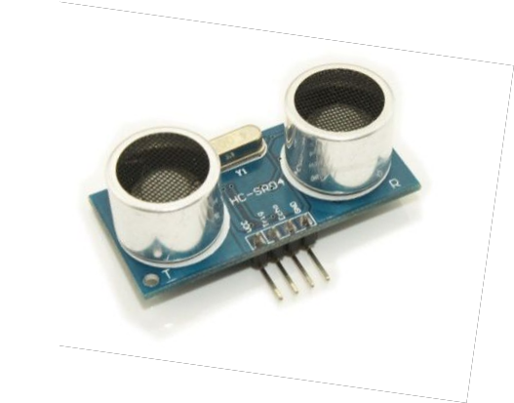

This is the HC-SR04 ultrasonic ranging sensor. This economical sensor provides

2cm to 400cm of non-contact measurement functionality with a ranging accuracy that can reach up to 3mm. Each HC-SR04 module includes an ultrasonic transmitter, a receiver and a control circuit.

CIRCUIT DIAGRAM:

**1. CAR**

**Schematic View**

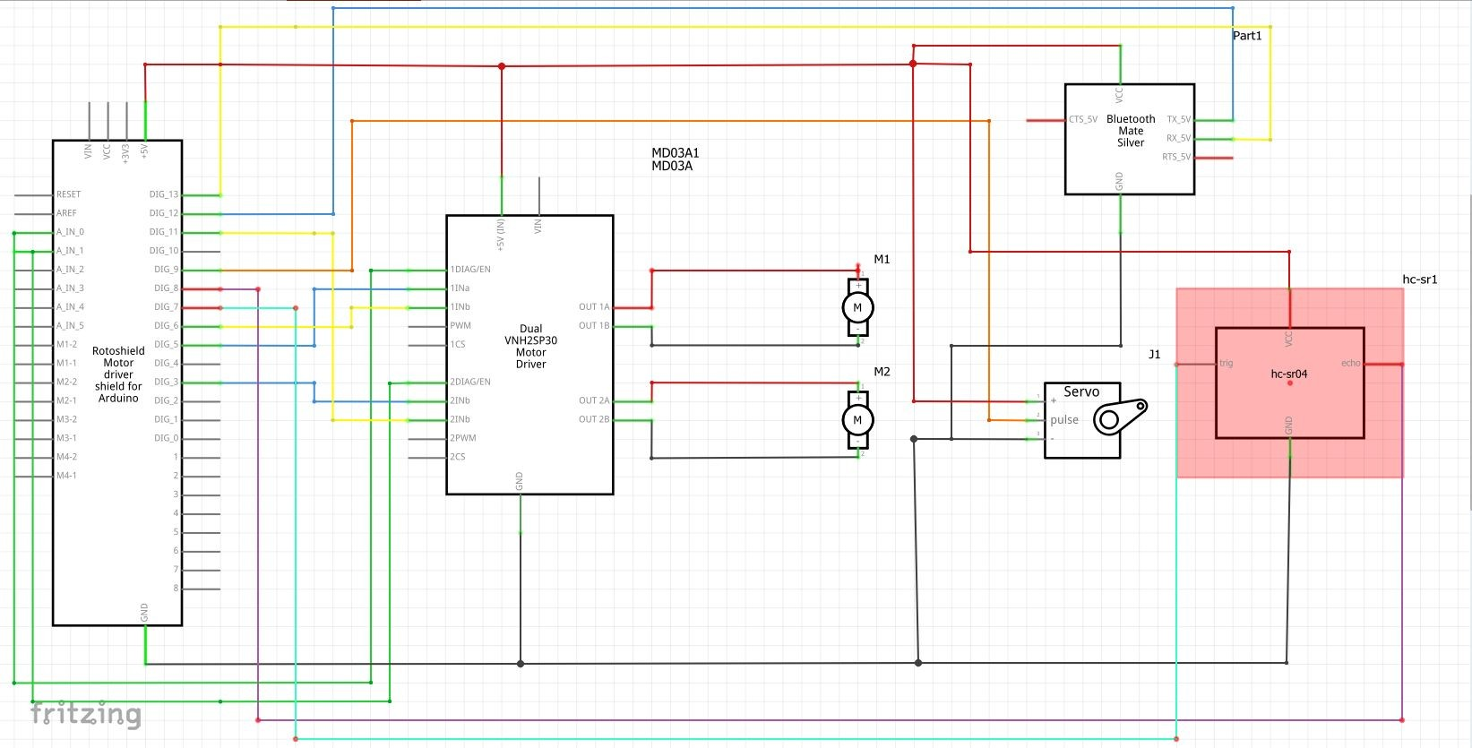

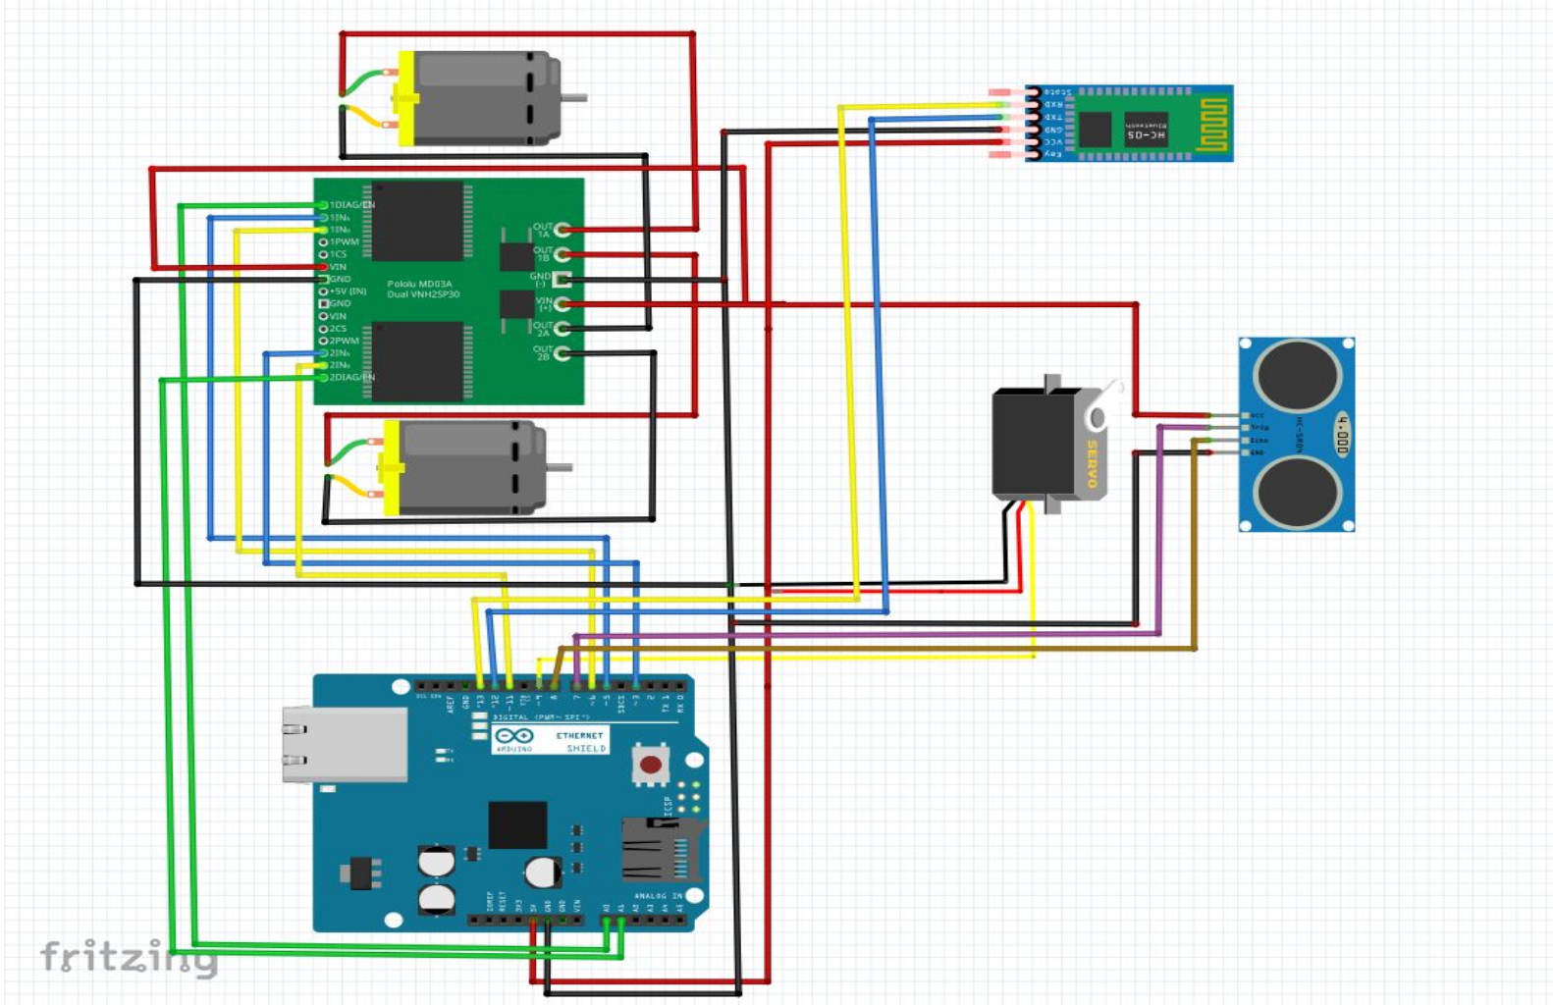

APPLICATIONS:

With proper programming, we can use it as a weight lifter, auto parking assistance.

By making small changes in software this system can be used for avoiding concealed paths.

GALLERY:

**1. CAR:**

